**Configuring RDP Control Settings**  
  
Purpose:  
  
**RDP Control > Settings** allows you to configure Remote Desktop Protocol (RDP) settings and RDP display window parameters. Two settings profiles (**default** and **rdp5_only**) are configured by default. To create your own custom settings profile, complete the following steps.   
  
**Configuring RDP Control Settings**

1. Navigate to **Main menu > RDP Control > Settings**.

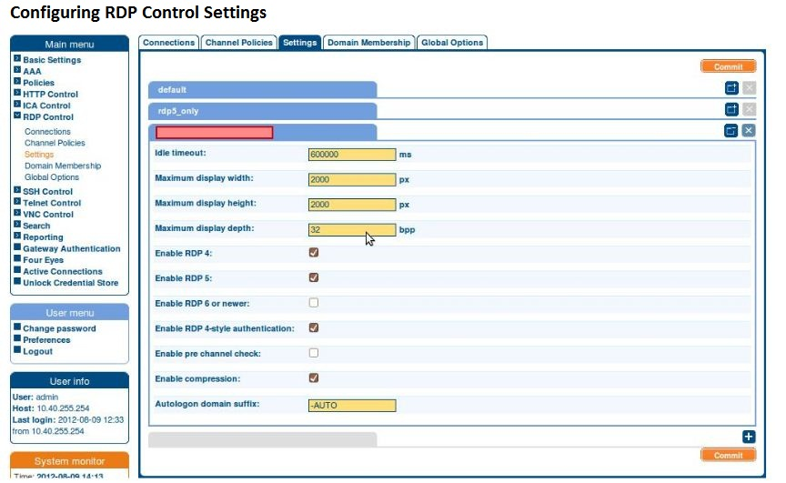

1. To create a new custom settings profile, click .

| TIP: To close a settings profile tab, click .

| TIP: To open a settings profile tab again, click .

| TIP: To delete a custom settings profile, click .

1. To name your custom settings profile, enter a name into the empty red field.

| TIP: Use informative names, for example, user_office_secure_1.

1. Configure the settings below:
   1. To set idle timeout, enter a value larger than 1 into the **Idle timeout** field in milliseconds.

| CAUTION: To avoid data loss, remember to calculate the value in milliseconds.  
 To calculate the value you need, multiply the number of seconds by 1,000 or the  
 number of minutes by 60,000.   
 Examples: 1 second equals 1,000 milliseconds.   
 1 minute equals 60,000 milliseconds.

For further help, click [here](https://www.inchcalculator.com/convert/time/) to navigate to an online calculator.

* 1. To set the maximum display width value for the RDP display window, enter a value larger than 1 into the **Maximum display width** field in pixels.
  2. To set the maximum display height for the RDP display window, enter a value larger than 1 into the **Maximum display height** field in pixels.
  3. To set the color depth value for the RDP display window, enter the suitable value (1 | 8 | 16 | 32 | 64 ) into the **Maximum display depth** field in bits per pixel.

| TIP: To determine optimal color depth if unsure, click [here](https://en.wikipedia.org/wiki/Color_depth) for further  
 information.

* 1. To select which RDP version you want to allow, select one or more of the options **Enable RDP 4** | **Enable RDP 5** | **Enable RDP 6 or newer**.

| TIP: To avoid compatibility problems, select  **Enable RDP 4-style authentication**.

* 1. To allow an evaluation before the connection is established, select **Enable pre channel check**.
  2. To reduce the risk of network overload during RDP sessions, select **Enable compression**.

| CAUTION: Failing to allow **Enable compression** may result in an increase in  
 network overload by up to 500%.

* 1. To change the default autologon suffix -AUTO, enter the preferred suffix into **Autologon domain suffix**.

1. To save your custom settings profile, click .

| TIP: To create more custom settings profiles, repeat steps 1-5 after saving the profile.

| TIP: To select the custom settings profile you want to use later, navigate to  
 **Main menu > RDP Control > Connections**.